*Affirmation of Faith
In life and in death we belong to God. Through the grace of our Lord Jesus Christ, the love of God, and the communion of the Holy Spirit, we trust in the One Triune God, the Holy One of Israel, whom alone we worship and serve.
In gratitude to God, empowered by the Spirit, we strive to serve Christ in our daily tasks and to live holy and joyful lives. With believers in every time and place, we rejoice that nothing in life or in death can separate us from the love of God in Christ Jesus our Lord. Glory be to the Father, and to the Son, and to the Holy Spirit. Amen.
From: A Brief Statement of Faith, Presbyterian Church (USA)

*Hymn No. 450 Be Thou My Vision

*Charge & Benediction
Offering: Giving does not buy you God’s love—that is free. Giving simply helps keep our heat on, our ministries going, and our staff, paid.
An offering plate is found at the front of the sanctuary. You may also mail or PayPal a donation.

We affirm our faith together because as diverse as we are, as differently as we vote, as many interests as we have, we have these beliefs that we share.

Benediction is a fancy word for blessing.

Worship Notes
Some of today’s liturgy is used with permission from enfleshed.
Music is printed and recorded under the CCLI #CSPL121737 & 11497292

*Share the Peace of Christ
Go now in peace, go now in peace, May the love of God surround you everywhere, everywhere you may go.

Worship Leaders
Clerk of Session, Rey Spangler
Session: Janine Scaccia, Betsy White,
Kristi Leone, Trish Lehnen, Rey Spangler, Matthew Carman
Admin. Response Team: Rey Spangler, Matthew Carman, Betsy White
Deacons of the Month for February Melissa Chwojdak and Sandi Askin

Pastor, The Rev. Holly Clark-Porter
Parish Associate, The Rev. Zoe
Milliman
Director of Music, Lily Li
Childcare Staff: Reece Lehnen
Liturgist, Melissa Chwojdak
Fred Kids teacher, Katie Sanders

ALL ARE WELCOME to a time of fellowship from 11:30-12:15 after the service today in the Fellowship Hall.

As a reminder, we're no longer putting an "insert" of announcements in all the bulletins. A handful can be found in our lobby or on our Worship & Spirituality page. This insert includes our prayer list.

Give a
Secure Donation
using PayPal.
Use the drop down to give to a certain fund.



Fredonia Presbyterian Church 219 Central Ave., Fredonia, NY 14063
www.fredoniapres.org
716-679-1501



Fredonia Presbyterian Church
February 15, 2026
Transfiguration of the Lord
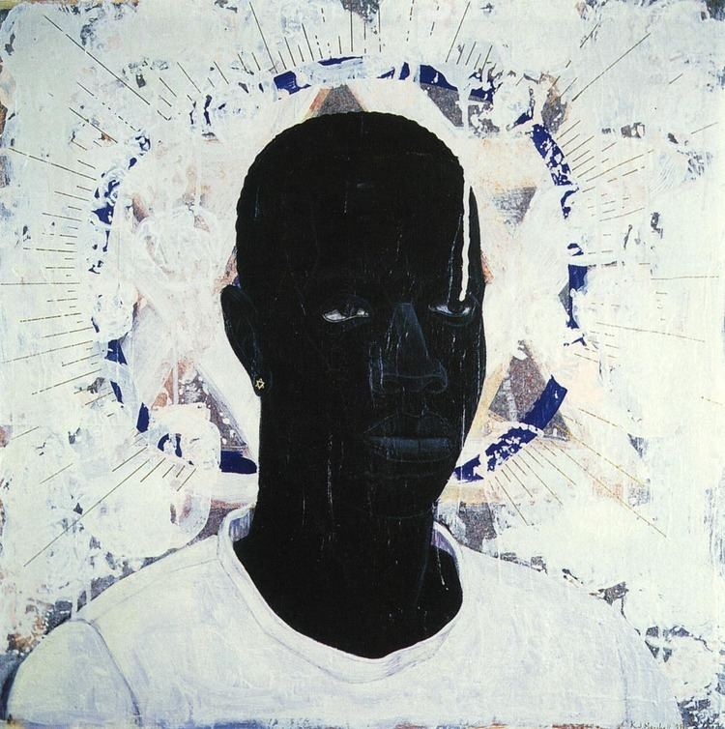
Lost Boy AKA Black Johnny, 1993, Kerry James Marshall

Prepare for Worship
Welcome to worship, where God gathers us in the name of love. At FPC, we hope to be challenged by Scripture, comforted by community, and energized by service. If you’re new here or it’s been a while, we’re glad you walked in today. For more, check out the bulletin insert. All people: toddlers, teenagers, Gen Xers, Boomers and beyond, LGBTQIA+ folx, conservative or liberal people, and those with differing abilities and mental health—all—are cherished and affirmed here.
Gather
Catch up with one another as you come in! When the chiming of the hour sounds, please keep the silence as we prepare for worship.

Reformed worship centers around the Word, both the Word of scripture and Christ as the Word incarnate. Worship, then, is our communal and individual response to the Word.

Bold text is read by the congregation in one voice.

*Please rise in body or in spirit.

Confession isn’t to prove you’re pious. It’s to help rebuild connections between you and God, you and yourself, you and others, and us and the world.

Prelude - Lily Li

Chiming of the Hour
Use this moment of silence to gather your heart and mind as we prepare for worship.

Welcome & Announcements

Choral Introit - The Choir

*Call to Worship - Liturgist, Melissa Chwojdak
One: We have climbed this mountain before.
All: We have come looking for God.
One: Sometimes in thunder. Sometimes in cloud. Sometimes in dazzling
light.
All: Sometimes in silence.
One: On Sinai, God’s glory wrapped the mountain in cloud. On another
mountain, Jesus’ face shone like the sun.
All: Holy Mystery, we are ready to see — even if it changes us.
One: Come, let us worship the One whose glory is not contained by stone
tablets or shining faces
All: but who meets us here, and sends us shining into the world.

*Hymn No. 192 Shine, Jesus, Shine

CALL FOR THE OFFERING In lieu of passing the plates, please use this time to consider your gift to the church.

Unison Prayer of Dedication
God of light and love, we offer these gifts to you, not because they are perfect, but because they are given with hope. Take what we bring and use it for justice, mercy, and care. Help us carry your light into the places that need it most. Amen.

HYMN NO. 606 DOXOLOGY Praise God, from whom all blessings flow; praise God all creatures here below; praise God above, ye heaven-ly host; *praise Father, Son, and Holy Ghost. Amen. *Or Creator, Christ, and Holy Ghost

Call to Confession and Silent Confession (You are invited to share your wrongdoings and sorrows with God).

Unison Prayer of Confession
God of dazzling light and quiet presence, we confess that we are often afraid of change: afraid of what it might ask of us, afraid of what it might reveal.
We confess that when things get uncomfortable, we want to build tents and stay put, to freeze moments of beauty instead of following you back down the mountain.
We confess that we listen selectively, eager for your voice when it affirms us, hesitant when it challenges us.
Forgive us, God. Forgive our fear.
Forgive our half-listening hearts.
Teach us again how to trust you. Amen.

Assurance of Pardon
One: We are forgiven, healed, and made whole. May all God’s people say,
All: Amen

Sung Response to the Assurance of Pardon
Hymn No. 354 Mine Eyes Have Seen the Glory, vs 1 & 2

Word

Prayer of Illumination

Hebrew Text: Exodus 24:12-18

Choral Anthem

Moment with Young Disciples
After this time, children 3-12 are invited to attend Fred Kids! a time for faith-formation and fun.

Gospel: Matthew 17:1-9
One: The Word of the Lord All: Thanks be to God

Sermon

Musical Reflection - Lily Li

Ordination and Installation Elder: Matthew Carman
Engage
Scripture: Our pastor (usually) follows the Revised Common Lectionary, an ecumenical, Biblical reading program. This helps the Holy Spirit move into places we might otherwise miss.
Our Choir: Anyone can join the choir. They practice Sunday mornings at 9:30. Just show up!
The Lord’s Prayer: We use “debts and debtors” in the Lord’s Prayer. If you’re more comfortable with the “trespass” language, please use it. Or if this prayer is meaningful to you in a different language, pray it that way. We all get to “Amen” together.
Communion: Served on 1st Sundays. Anyone, regardless of age or membership, is invited to partake. We use non-alcoholic grape juice. Gluten free bread is available with its own cup. If you're nervous, just ask someone. You can't mess this up (although sometimes, we do make a mess and that's okay too!)

Prayers of the People & The Lord’s Prayer
Our Father who art in heaven, hallowed be Thy name. Thy kingdom come, Thy will be done, on earth as it is in heaven. Give us this day our daily bread and forgive us our debts as we forgive our debtors.
Lead us not into temptation but deliver us from evil. For Thine is the kingdom and power and the glory forever. Amen.

