Words of Institution & Sharing of Communion

Prayer after Communion & Prayers of the People

*AFFIRMATION OF FAITH
I believe in God, the Father Almighty, Creator of heaven and earth.
I believe in Jesus Christ, God’s only Son, our Lord, who was conceived by the Holy Spirit, born of the Virgin Mary, suffered under Pontius Pilate, was crucified, died, and was buried; he descended to the dead. On the third day he rose again; he ascended into heaven, he is seated at the right hand of the Father, and he will come to judge the living and the dead.
I believe in the Holy Spirit, the holy catholic Church, the communion of saints, the forgiveness of sins, the resurrection of the body, and the life everlasting. Amen.

*Hymn No. 32 I Sing the Mighty Power of God

*Charge & Benediction
Offering: Giving does not buy you God’s love—that is free. Giving simply helps keep our heat on, our ministries going, and our staff, paid.
An offering plate is found at the front of the sanctuary. You may also mail or PayPal a donation.

We affirm our faith together because as diverse as we are, as differently as we vote, as many interests as we have, we have these beliefs that we share.

Benediction is a fancy word for blessing.

Worship Notes
Some of today’s liturgy is used with permission from enfleshed.
Music is printed and recorded under the CCLI #CSPL121737 & 11497292

*Share the Peace of Christ
Go now in peace, go now in peace,
May the love of God surround you everywhere,
Everywhere you may go.
Session: Rey Spangler, Kristi Leone,
Trish Lehnen, Janine Scaccia Matthew Carman, Betsy White
Response Team: Rey Spangler, Matthew Carman and Betsy White
Deacons of the Month for October
Jenn O’Boyle and Sandi Askin

Worship Leaders
Pastor, The Rev. Holly Clark-Porter
Parish Associate,
The Rev. Zoe Milliman
Director of Music, Lily Li
Liturgist, Trish Lehnen
Childcare Staff: Reece Lehnen
Fred Kids Teacher: Katie Sanders

Fredonia Presbyterian Church
219 Central Ave., Fredonia, NY 14063
www.fredoniapres.org
716-679-1501
ALL ARE WELCOME to a time of fellowship from 11:30-12:15 after the service today in the Fellowship Hall.

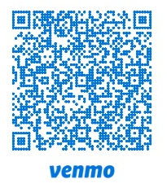
Give a
Secure Donation
using PayPal.
Use the drop down to give to a certain fund.



Fredonia Presbyterian Church
October 4, 2026
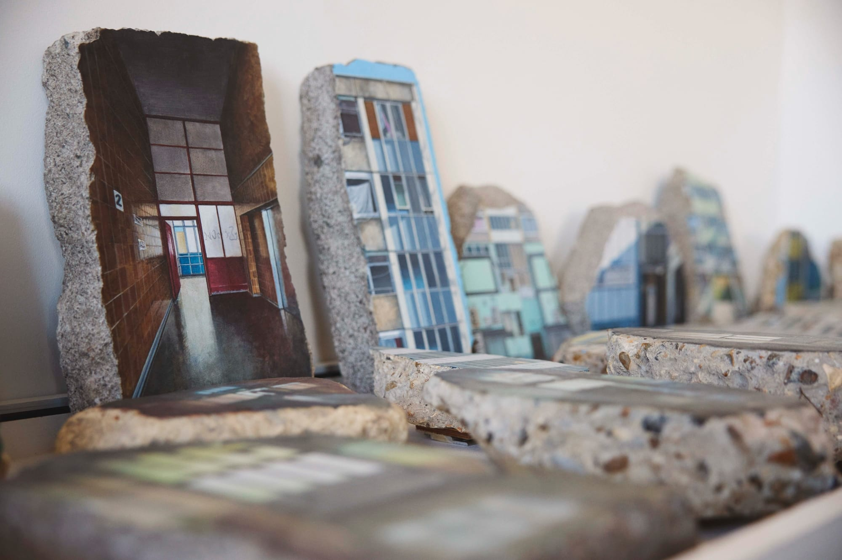 Studio View, Harriet Mena Hill. Photo, Jon Cardwell. After demolition, Hill took pieces of concrete and painted the Estate. ‘On Concrete Remnants of London’s Aylesbury Estate,’ Hill Preserves a Community.
Prepare for Worship
Welcome to worship, where God gathers us in the name of love. At FPC, we hope to be challenged by Scripture, comforted by community, and energized by service. If you’re new here or it’s been a while, we’re glad you walked in today. For more, check out the weekly guide. All people: toddlers, teenagers, Gen Xers, Boomers and beyond, LGBTQIA+ folx, conservative or liberal people, and those with differing abilities and mental health—all—are cherished and affirmed here.
Gather
Catch up with one another as you come in! When the chiming of the hour sounds, please keep the silence as we prepare for worship.

Reformed worship centers around the Word, both the Word of scripture and Christ as the Word incarnate. Worship, then, is our communal and individual response to the Word.

Bold text is read by the congregation in one voice.

*Please rise in body or in spirit.

Confession isn’t to prove you’re pious. It’s to help rebuild connections between you and God, you and yourself, you and others, and us and the world.

Prelude - Lily Li

Chiming of the Hour
Use this moment of silence to gather your heart and mind as we prepare for worship.

Welcome & Announcements - Rev. Holly

Stewardship Moment

Choral Introit - The Choir

*Call to Worship - Trish Lehnen
One: Come, let us worship the God who gives us more than we could ever
earn.
All: We come with grateful hearts and open hands.
One: Come, let us worship the God who calls us to care for what has been
entrusted to us.
All: We come ready to listen, to receive, and to share.
One: Come, let us worship the God who is always making room for
something new.
All: We are here. We are ready. Let us worship God.

*Hymn No. 401 Gather Us In, vs 1-3

CALL FOR THE OFFERING In lieu of passing the plates, please use this time to consider your gift to the church.

Unison Prayer of Dedication
Generous God, everything we have comes from you: our time, our money, our gifts, our relationships, this church, this community, and this beautiful, complicated life.
Receive these gifts as signs of our gratitude. May what we offer become part of something we cannot yet see—the kind of kingdom where there is enough, where no one is forgotten, and where love has room to grow. Amen.

HYMN NO. 606 DOXOLOGY
Praise God, from whom all blessings flow; praise God all creatures here below; praise God above, ye heavenly host; *praise Father, Son, and Holy Ghost. Amen. *Or Creator, Christ, and Holy Ghost

Call to Confession and Silent Confession (You are invited to share your wrongdoings and sorrows with God)
Unison Prayer of Confession
God of the vineyard, we confess that we sometimes forget that our lives are gifts.
We cling to what we have as though we earned it alone. We protect what is comfortable and call it wisdom. We resist change and call it faithfulness. (prayer continues)
Forgive us for the ways we have treated your gifts as possessions. Forgive us when we reject the voices that challenge us, especially when those voices are telling us something we do not want to hear.
Give us the courage to remember that everything we have is entrusted to us for the sake of love.
And when we fail—and we will—meet us again with mercy. Teach us how to begin again. Amen.

Assurance of Pardon
One: We are forgiven, healed, and made whole. May all God’s people say,
All: Amen

Sung Response to the Assurance of Pardon
Hymn No. 418 Softly and Tenderly Jesus Is Calling, vs 1 & 2

Word

Prayer of Illumination

Hebrew Text: Psalm 80:7-15

Choral Anthem

Gospel: Matthew 21:33–46
One: The Word of the Lord
All: Thanks be to God

Sermon - Rev. Holly

Musical Reflection - Lily Li

Engage

Invitation to Communion

Great Prayer of Thanksgiving
One: The Lord be with you.
All: And also with you.
One: Lift up your hearts.
All: We lift them up to the Lord.
One: Let us give thanks to the Lord our god.
All: It is right to give our thanks and praise.
(The Great Prayer continues)

Our Father who art in heaven, hallowed be Thy name. Thy kingdom come, Thy will be done, on earth as it is in heaven. Give us this day our daily bread and forgive us our debts as we forgive our debtors.
Scripture: Our pastor (usually) follows the Revised Common Lectionary, an ecumenical, Biblical reading program. This helps the Holy Spirit move into places we might otherwise miss.
Our Choir: Anyone can join the choir. They practice Sunday mornings at 9:30. Just show up!
The Lord’s Prayer: We use “debts and debtors” in the Lord’s Prayer. If you’re more comfortable with the “trespass” language, please use it. Or if this prayer is meaningful to you in a different language, pray it that way. We all get to “Amen” together.
Communion: Anyone, regardless of age or membership, is invited to partake. We use non-alcoholic grape juice. Gluten free bread is available with its own cup. If you're nervous, just ask someone. You can't mess this up (although sometimes, we do make a mess and that's okay too!)

Lead us not into temptation but deliver us from evil. For Thine is the kingdom and power and the glory forever. Amen.

