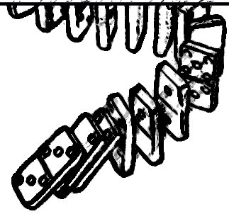
Domino Effect:
Every gift starts something

First Name(s) _______________________________________
_______________________________________
Last Name _______________________________________
Address _______________________________________

City____________________ Zip__________

Email ___________________________________
Phone ___________________________________
For 2026, I/we will give (choose one):
____________________ dollars weekly.
____________________ dollars monthly.
____________________ dollars annually.
This pledge may be revised at anytime
by notifying our office
--------
Thanks for your gift of pledged money. Your pledge enables us to create the budget that supports our open and affirming congregation as we feed people spiritually and literally.
"The kingdom of heaven is like a mustard seed... the smallest of all the seeds, but when it has grown it is the greatest of shrubs..." Mat 13:31–32

--Fred Pres--
Fredonia, NY
When you give, you help us see the Holy Spirit in motion.
In 2027, I pray that God will work through Fred Pres so that together we can…
(write any hopes, dreams, ideas here!)
_______________________________________
_____________________________________________________________________________________________________________________
____________________________________________________________________________________________________________________________________________________________


And, for you we give thanks to God—for your voice, your opinions, your joy, your care, and your help. Amen.

