

**Fill the Fred Basket Month!**

We’re quite busy this month with our annual food drive. On Oct 9th & 10th at 2pm, we pass out bags & boxes to participants. On the 13th at 6:30 there is a photo opp at the Town of Arkwright board meeting. And on the 23rd, 24th, and 25th we pick up the filled baskets, on the 26th it is then blessed. If you can help with some or all of this, great! Let Holly, Susan P, or any member of session know.

October in Western New York has its own rhythm. The leaves flare up in reds and golds, the air carries that crisp bite of fall, and—let’s be honest—the conversations in line at Tops or after worship often circle back to *the Bills*. Whether you’re the kind who can recall every stat from the last game or just someone who enjoys the community spirit of it all, there’s something about this season that reminds us of the power of belonging.

Football, like church, is about more than the score. It’s about showing up. It’s about cheering even when things aren’t perfect (ahem--Baltimore). It’s about celebrating the victories, grieving the losses, and holding onto hope for “next Sunday.” In the same way, our life together as a congregation is not about perfection but about presence—showing up for each other, offering encouragement, and reminding one another that God is at work in us and through us.

As we head into October, our church calendar is full: worship, learning, service, and fellowship. I hope you’ll jump in—whether it’s joining a study, helping with an outreach event, or simply bringing your voice and heart to Sunday worship. Like any team, we need all our players.

So this season, whether you’re wearing red and blue on game day or your Sunday best in the pew, remember this: we belong to one another, and we belong to God. That’s good news, in every season.

Go Bills—and go Church!

The Fredonia Presbyterian

October 2025

Newsletter of the Fredonia Presbyterian Church

**From Our Pastor**

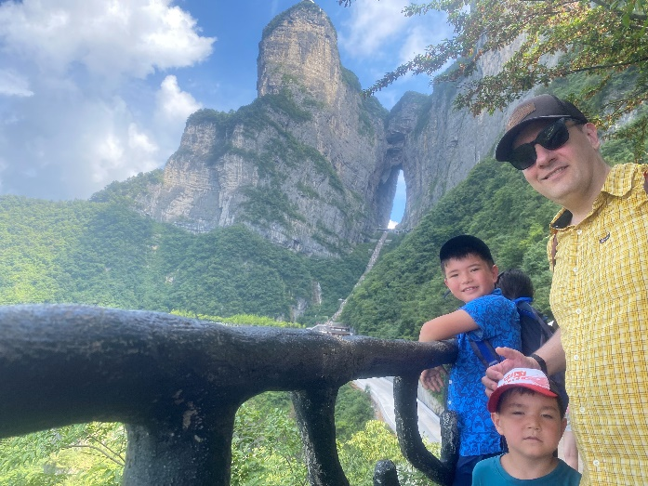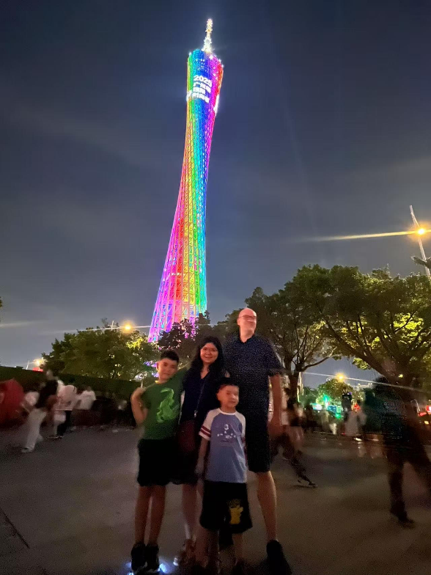

**Irish-Li family: Summer Travels -by John Irish**

Lily, John, Johnny, and Henry went to China this Summer for another visit to Lily's hometown: Guangzhou, Guangdong, China. We were in China from early July until mid-August, so we had a lot of time to both meet family and attend to personal matters, as well as do some travelling. John and Lily took the boys to some of the spots in that city they had never been, including the Guangzhou Tower and the Pearl River Bridge. The kids and Lily took an art class at the Guangzhou University of Fine Art, conveniently located near Lily's parents' home.

Besides Guangzhou, we spent a lot of time in Shaoguan, a smaller-sized city in the northern part of Guangdong province, close to the borders of Hunan and Jiangxi provinces. Shaoguan is where Lily's cousin lives, and he graciously took us along with his family on many sight-seeing day trips throughout that part of the province. These places included a few parks with pagodas and wonderful scenery, temples, and some great restaurants.

After our visit to Shaoguan, we made a trip to Hunan province, located to the north-west adjacent to Guangdong, travelling at great speed through the countryside via China's high-speed rail network. We dropped by Changsha, Hunan's provincial capital for a couple of days to see some of the scenic areas (and get some very spicy food!) and then went immediately to a place that had been on John's "bucket list" for some time: Hunan's amazing Zhangjiajie. This area is a unique sight. In fact, it is so other-worldly that the science fiction film Avatar was filmed there!

It was a great adventure for us, and we are thankful to Lily's family's hospitality, our good fortune, our health, and for the well-wishes of our Church family at Fredonia Presbyterian

**IN PLAIN VIEW -by Joe Calarco**

“Where have you seen Jesus?” Recently I began our men’s morning Bible Study with this question. After moments of thought, each of us shared an experience of our daily lives when we felt the divine presence of God. This opened my eyes to be more aware of God in my life.

As we cruised out of New York’s harbor, I stood by the ship’s rail watching the tall buildings silently slide by. Soon, others joined me, which grew to 50-60 lining the rail, anxiously looking forward. “There she is!” The noisy crowd became hushed in reverence as we approached a small island in the middle of the river. “Lady Liberty” stood majestically holding the flame of “enlightenment” high above her while in her other hand she clutched the tablet of “freedom”. I felt a rush of awe flow over me. Overcome with a sense of patriotism and spirituality, I uttered aloud, “God Bless America. One nation under God. In God we trust.” She is a symbol of America and God’s blessings …in plain view.

In Koinonia, a Christian Weekend retreat, we sing a song:

“Have you seen Jesus my Lord? He’s here in plain view.

Take a look, open your eyes, He’ll show life to you”.

In our daily lives of hustle and bustle, noise and distractions, are we missing God’s signs that He is here with us?

The other day I pulled into a parking space next to a “sketchy” car. The window was open next to me and the scent of stale cigarette smoke hit me. A young man was slouched down in his front seat with his window down. As I locked the door, I said, “Hi, how ya doing?” He looked at me blankly and I hurried into the store. I was hoping that he would be gone by the time I was done. But as I unlocked my door to leave, he spoke to me. “Do you remember me?” I looked at him blankly. He repeated haltingly, “Do you remember me? I’m Donald.” I looked into his window and 10 years passed in seconds. He was a student in a Special Class, and I was a substitute in his class from time to time. “Of course, I remember you, Donald”. We talked about his class so long ago. When I took his hand in mine, we both smiled. “God Bless You, Donald.”

“Open the eyes of my heart, Lord. I want to see you.”



**Gardeners! Got Plants?**

Are you dividing any perennials this fall? Consider giving a split to our Memorial Garden,

such a nice way to remember your loved one. We could especially use shade loving plants.

Text Trish, 716-785-8870

**To obtain a 4”x4” plaque for your loved one, see the form on our website under the**

**“Engage > Memory Garden” tab**

**Line from a Hymn**

**That Makes you go “hmm”**

“Let us build a house where all are named, their songs and visions heard”

-All Are Welcome

**Inspirations**

**Literature- Louise Erdrich, “Love Medicine” (book)**

**Music- Sufjan Stevens, “Casimir Pulaski Day” (song-folk)**

**Art- Pierre Huyghe, “Untilled (Liegender Frauenakt)” (sculpture)**

**Film- Pixar’s “Coco”**

The Fredonia Presbyterian

**Foods of the month** (oct)

Fried Dried Onions, Boxed Mashed Potatoes, Gravy & Stuffing Mix

**Deacon of the month** (sep)

Sandy Johnson

Thank you Sandy!

**Session Quick Notes from September Meeting:**

* All in favor in Welcoming Kenna, to become a member by Profession of Faith
* Discussion of Stewardship, excellent job by the committee, all going well
* Thank you to the Deacons for the picnic and all around stellar work
* On the docket: working on leadership, thinking about January 2026 nominations

October 2025

|  |  |  |  |  |  |  |  |
| --- | --- | --- | --- | --- | --- | --- | --- |
| Sunday | Monday | Tuesday | Wednesday | Thursday | Friday | Saturday | |
|  |  |  | 1 | 2 | 3 | 4 | |
| October is Spina Bifida Awareness Month |  |  | Food Pantry 12:30-4:30pm  Theology on Tap 5ish at Raven & Thorn | Narcotics Anonymous 7pm |  | Lakeshore Fellowship 12:30-7pm  Blessing of the Animals  11am | |
| 5 | 6 | 7 | 8 | 9 | 10 | 11 | |
| Choir Practice 9:30am  Worship 10:30am  School Supply Drive ends (but donations always appreciated!) | 5-9 Art Discovery | Deacons meet at 1 p.m. in the library | Food Pantry 12:30-4:30pm  Theology on Tap 5ish at Raven & Thorn | Narcotics Anonymous 7pm  2pm- meet at church to pass out bags & boxes to local participants of Fill the Fred Basket | 2pm- meet at church to pass out bags & boxes to local participants of Fill the Fred Basket | Fredonia Farmers Mkt  9am-1pm | |
| 12 | 13 | 14 | 15 | 16 | 17 | 18 | |
| Choir Practice 9:30am  Worship 10:30am  Fill the Fred Basket Begins at area businesses & offices | 5-9 Art Discovery |  | Food Pantry 12:30-4:30pm  Theology on Tap 5ish at Raven & Thorn | Narcotics Anonymous 7pm |  | | Food Pantry  10am-noon  Lakeshore Fellowship 12:30-7pm |
| 19 | 20 | 21 | 22 | 23 | 24 | 25 | |
| Choir Practice 9:30am  Worship 10:30am | 5-9 Art Discovery |  | Food Pantry 12:30-4:30pm  Compeer  12:30 – 2:30  Guy Time  3 – 4:30  Theology on Tap 5ish at Raven & Thorn | Narcotics Anonymous 7pm  Food Pickup-help appreciated! | Food Pickup-help appreciated! | Food Pickup-help appreciated!  FtFB ends | |
| 26 | 27 | 28 | 29 | 30 | 31 | 1 | |
| Choir Practice 9:30am  Worship 10:30am  Blessing the Bounty | 5-9 Art Discovery |  | Food Pantry 12:30-4:30pm  Theology on Tap 5ish at Raven & Thorn | Narcotics Anonymous 7pm | Halloween | Dia de los Muertos | |

The Fredonia Presbyterian



October Anniversaries

October Birthdays

Images from Bing.

The Fredonia Presbyterian

2 Reece Lehnen

8 David Tiffany

9 David Dawes

10 Barbara Lucariello

11 Calvin Gordon (born 2023)

12 Leah Bennett

Jean Dawes

13 Brittany Valente

14 Kate Piazza

Glen Bennett

16 Tatum Piazza-Harvey

20 Rey Spangler

AJ Amatuzzo

25 Lucy Andrus

26 Faith Phillips

27 Audrey Divine

29 McKenna Miller

30 Ellen Foley

2 Tom & Betsy White 1993

9 Brett & Audra Comerford 2004

Trisha & Paul Lehnen 2004

10 Tom Gordon & Cindy Rechlin 1987

22 Tom & Renee Salamone 2011

Around Town

**(**see page 4 calendar for events specific to our church)**

Saturday 10/4 6pm, Sheridan VFW

“Monte Carlo Night”

To benefit the Sonshine Charitable Fund

Thursday 10/16 7pm, King Hall SUNY Fred

“US Air Force Concert Band &

Singing Seargents”

(free but must have a ticket through the office in the Williams Center)

Saturday 10/18 1pm, Peace of Mind Center,

260 Central Ave, **Silver Creek**

**“**Tea & Talk: Divorce/Separation”

(Donations happily accepted but not required)

Saturday 10/25 1pm,

6 Cleveland Ave,Lily Dale

“Meet the Fairies of Lily Dale”

(Donations happily accepted but not required)

**New Baby!!**

So many congratulations to Ryan & his sister and family! Ryan’s niece

Bristol Patricia Jean Draggett

was born September 12th, 2025

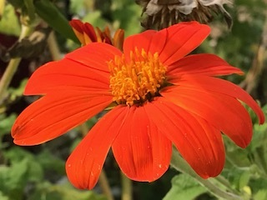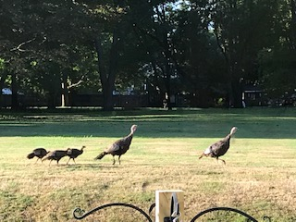

Ron Scaccia

10/20/24

Carmen Yongqing Li

Deb Carrie

Sharyn Duff-Kibbee Kathy

Laurie Crystal & baby

Wayne Lenny & Cathy

Jenn O’Boyle Lourdes

Julie Newell Diane Bell

Wayne & Susan Susan Faust

Margaret Kohl Sarah Annerose Pietsch Kyrie

Donna Rocque Jenna

Brian Sisson Rey Spangler

Frank & Mary Tucker

Greg Chwojdak Amanda Foy

Gary Chwojdak Lisa Dubenion

Nardel Hector Grandma Tarele

Holly Clark-Porter Diane Bell Susan Faust

Jennifer & Mike Joe Dolce

Jonah & Elijah Lorraine

Shaundra & Art The English Family

In Memoriam

Prayer List

The Fredonia Presbyterian

The Fredonia Presbyterian

|  |
| --- |
|  |
|  |

|  |
| --- |
|  |

|  |
| --- |
|  |
|  |

Prayers…

For those feeling the effects of breast cancer, ADHD, pregnancy and infant loss, domestic violence. October is awareness month for all of these.

For our brave girl, Elliana, during Spina Bifida Awareness month. We learned so much during your speech a few months ago, thank you, E!

For our Global Partners in Ministry; Friends of the Presbyterian Education Board in Pakistan, and the young girl we sponsor, Neriah.

October! Trees afire, leaves crunching underfoot on increasingly chilly walks. A bounty of apples and pumpkins, delicious in pie. Spooky season; costumes prepared and anticipated, treats hoped for, our dear departed perhaps feeling nearer in our cozy contemplations. We thank you Lord, for the blaze of glory that is October, before all rests.

-Original Photographs by Carol Groat

Fredonia Presbyterian

219 Central Ave

Fredonia, NY 14063

Special Events in October

Saturday 10/4 11AM- Blessing of the Animals

10/12-10/25- **Fill the Fred Basket** areawide food drive. Non-perishable items collected at several townships’ businesses and offices. See calendar for ways to help.

10/23-10/25- Pick up foods from food drive local participants. Help appreciated! Let Susan Pepe or any session member know.